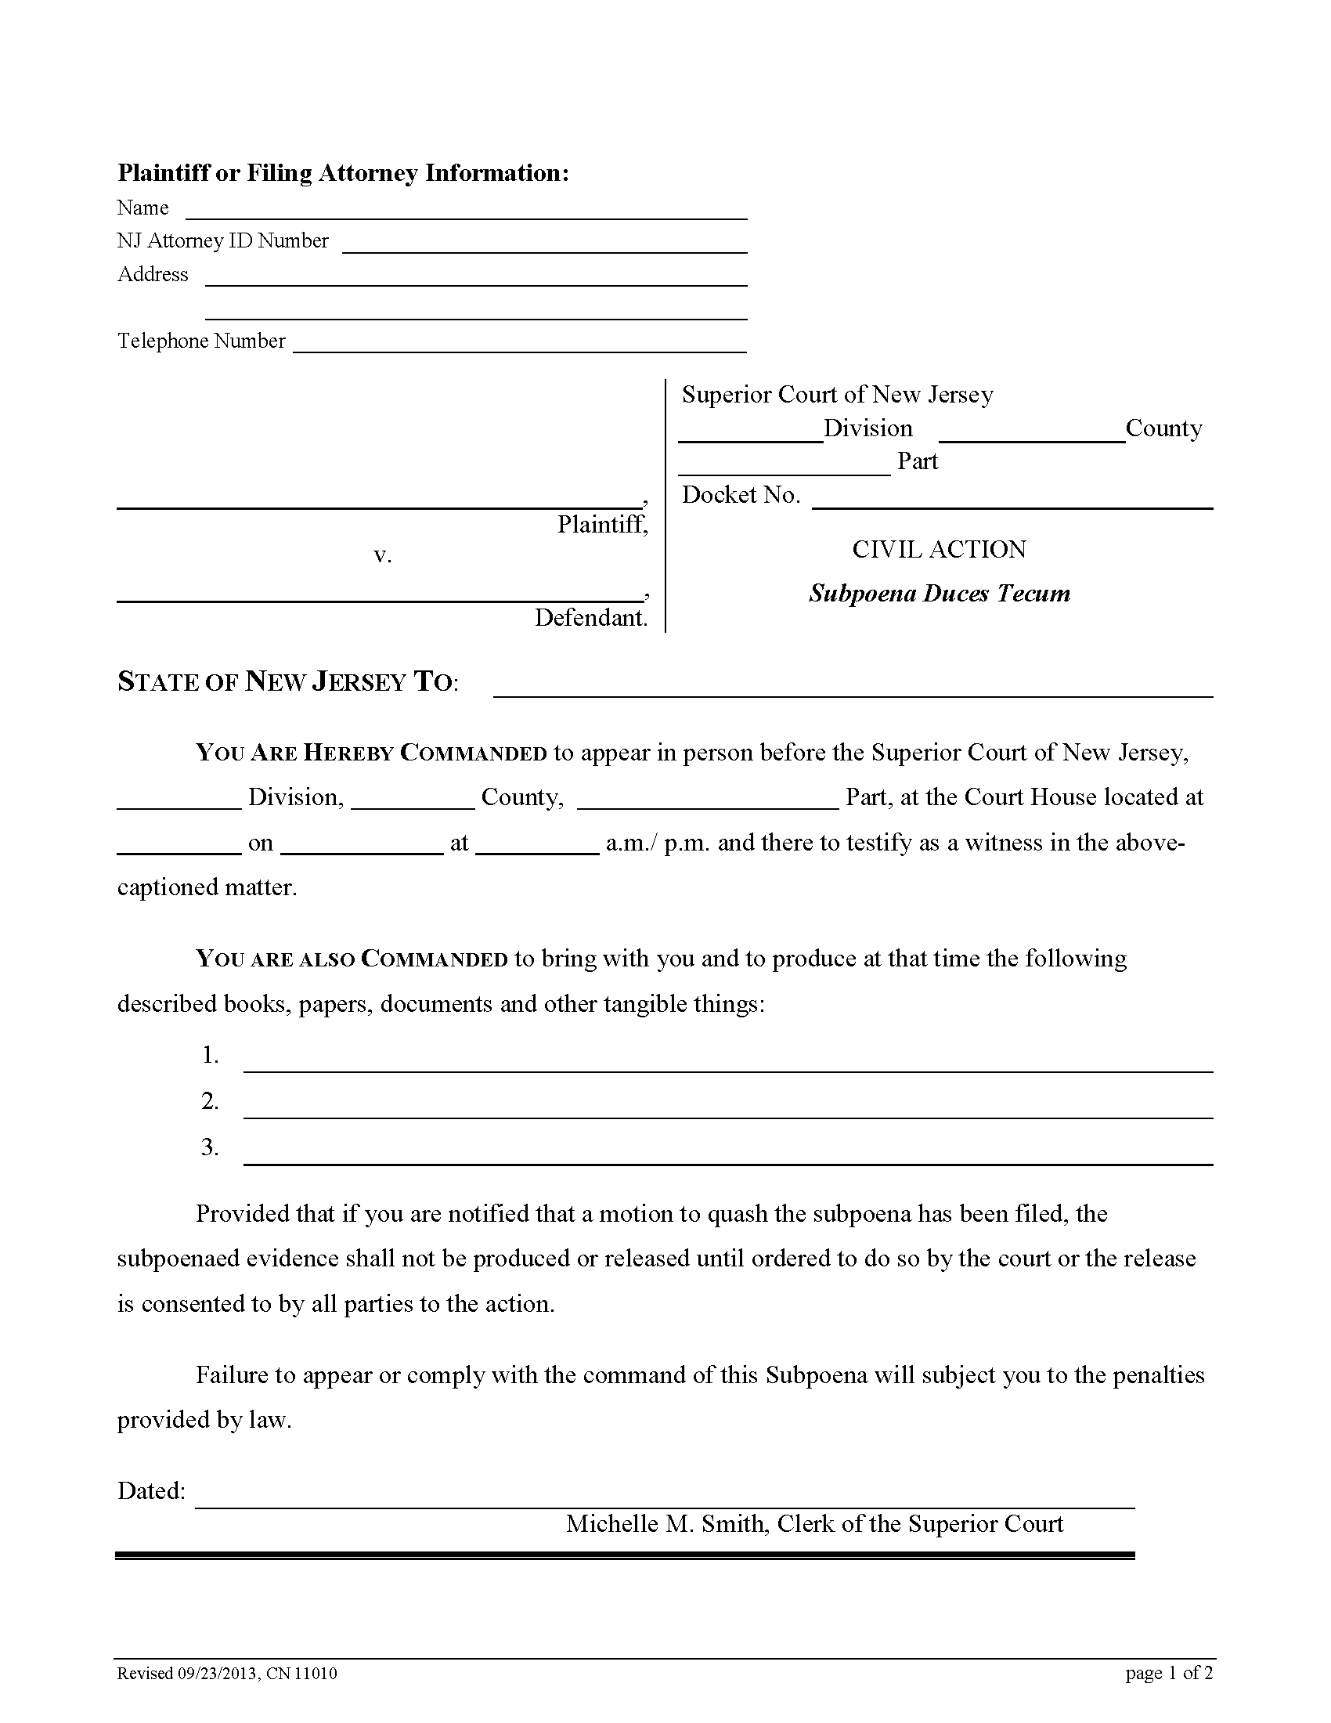
Batman
Gotham City

99-99999
FROM 01/01/1979 TO PRESENT: Any and all MEDICAL RECORDS, including but not limited to patient history form(s), reports, etc. pertaining to Batman SSN: xxx-xx-5555, DOB: 01/01/1979.
CUSTODIAN OF RECORDS
University of Michigan Hospital and Health Center
2901 Hubbard Street Room 2722
Ann Arbor, MI 48109-0000
John Doe

123 East Main Street
Anywhere, MI 12345
(123) 456-7890

Order Number: 01-29018-002
Law
to produce records on 03/15/2016 at 10:00 A.M. at the Law Offices of
Smith and Jones PC, John Doe
C/O Axiom Requisition Copy Service 2869 Jolly Road Okemos, MI 48864
on the part of
Gotham City
Michelle M. Smith
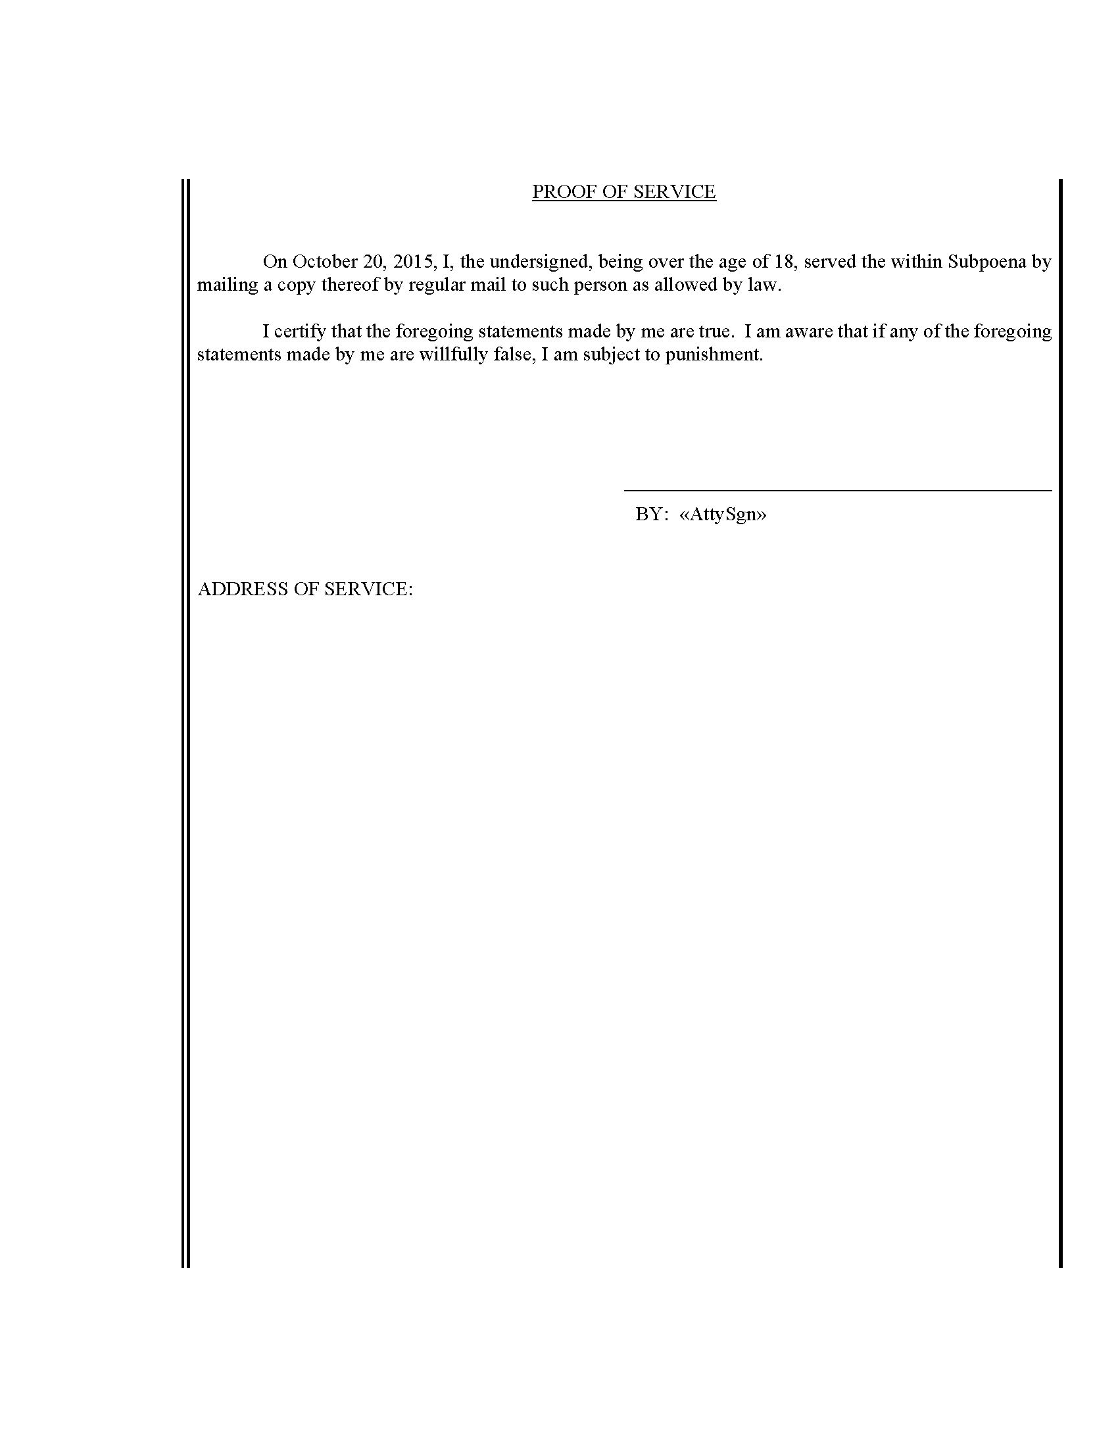
John Doe
John Doe
CUSTODIAN OF RECORDS
University of Michigan Hospital and Health Center
2901 Hubbard Street Room 2722
Ann Arbor, MI 48109-0000

Order Number: 01-29018-002
John Doe
Order Number: 01-29018-002
CUSTODIAN OF RECORDS
University of Michigan Hospital and Health Center
2901 Hubbard Street Room 2722
Ann Arbor, MI 48109-0000

